Htet Tee
METC 143
Paul Verdeyen
9/19/15
Lab 1 Week 3
Hardness Test Lab
Background:
C1010 steel pipe is currently used in production. The part the pipe is used is having issues on the production floor. The dimensions of the part are not correct. The Quality Manager suspects the hardness of the material may not be right. The print for the oil pipe states the material is supposed to have a Rockwell B hardness of 80 to 85.
Procedure:
Test oil pipe hardness on the hardness machine.
Questions to Answer:
Given Material hardness specification,
When we test it the pipe is about 54 Rockwell B and base on what the instructor said it should be 80 to 85.
Does the oil pipe hardness meet the specification?
No, because the pipe is supposed to be around 80 to 85 Rockwell B but when we test it the pipe was lower than expected.
What would you recommend to the Quality Manager regarding the material?
The pipe is not meeting the standard and requirement that we expected so we will not let anyone use
This material1.Production is currently using the oil pipe, what steps would you take if the material does not meet the hardness requirements?
Recheck Edge Dislocation and see what solution that can be done to improve the hardness of the material.

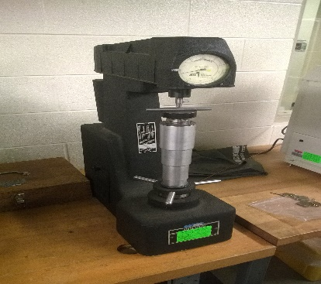This is Wilson-16-11 hardness tester.

